EVENT BAG PROCEDURES
Backpacks, drawstring bags, or bags are NOT permitted inside the facility with the exception of one of the following, per person.
-One purse or;
-One small clutch bag or wristlet.
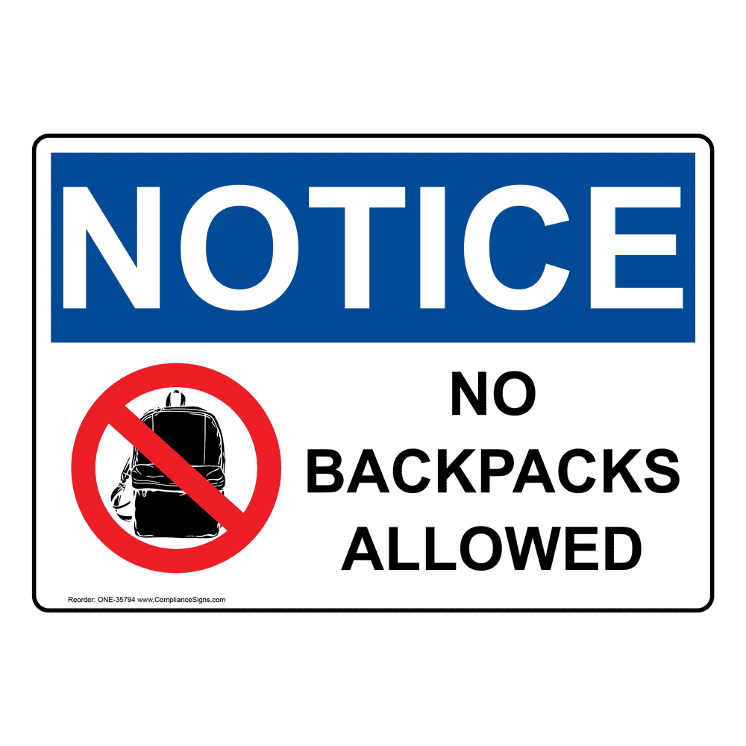
-Clothing, blankets, cameras and cell phones will be permitted if carried loosely.

-Diaper bags, strollers, walkers and other medically necessary items will be permitted following a detailed search.

ALL BAGS AND PERSONAL ITEMS ARE SUBJECT TO SEARCH

